**PROSECUTORS’ CENTER FOR EXCELLENCE**

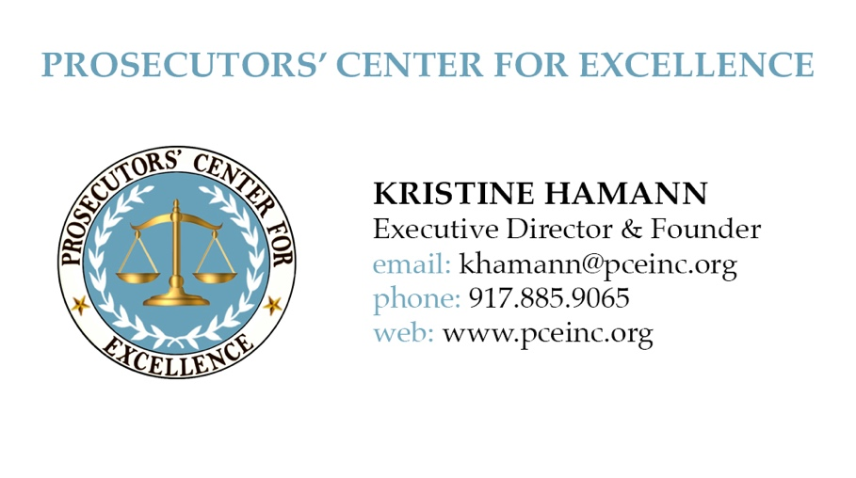

**The Conscious Prosecutor**

In the pursuit of justice, prosecutors must be fact-based and fair. They cannot base their judgements on whim, bias or hunches. However, studies have shown that all people have implicit biases that could influence their decisions. Training can help prosecutors to understand this issue and provide strategies for assuring that prosecutorial decisions are based on the facts and not predisposed by irrelevant implicit biases. This tool kit, compiled in collaboration with the National Black Prosecutors Association, offers information about the trainings recommended by various prosecutor offices, as well as links to additional materials and resources on the issue of implicit bias.

**Speakers on Implicit Bias (in alphabetical order)**

**Prosecutor Training 2016**

Speaker: Mahzarin Banaji

Website: <https://en.wikipedia.org/wiki/Mahzarin_Banaji>

You Tube: <https://www.youtube.com/watch?v=brjnJ1NFr1E>

Where: Manhattan DA’s office, NY

Speaker: Kimberly Burke, Center for Policing Equity. Phil Goff, Co-Founder and President

Website: <http://policingequity.org/>

Where: DC US Attorney’s Office, Washington DC

Speaker: Lorie Fridell

Website: <http://www.fairimpartialpolicing.com/>

You Tube: <https://www.youtube.com/watch?v=qL25kGM-HUw>

Where: Statewide anti-gun violence program in New York State for police and prosecutors.

Speaker: Doug Harris, “The Kaleidoscope Group” (Chicago based group)

Website: <http://kgdiversity.com/doug-harris/>

You Tube: <https://www.youtube.com/watch?v=Qq5rtZXt-1A>

Where: NYC Law Department (the Law Department does mostly civil cases for New York City, but they have a Family Court prosecution unit.), NY

Speaker: Mark Katrikh of the Museum of Tolerance in LA

Website: <http://www.museumoftolerance.com/site/c.tmL6KfNVLtH/b.5335861/k.DA90/POST_Certified_Training_at_the_Museum_of_Tolerance.htm>

Where: Yolo County DA’s Office, CA

Consultant: Verna Myers

Website: http://vernamyers.com

You Tube: Ted Talk: <http://vernamyers.com/portfolio/ted-walk-toward-biases/>

Where: Manhattan DA’s Office, NY

Speaker: Prof. Kim Norwood, Washington University in St. Louis

Website: <http://blackleadershiproundtable.org/main/index.php/kimberly-jade-norwood>

You Tube: <https://www.youtube.com/watch?v=izopZwule9Y>

Speaker: Kimberly Papillion

Website: <https://thebettermind.com/>

You Tube: <https://www.youtube.com/watch?v=kXejP5UadEk>

Where: San Francisco DA’s Office, CA

Speaker: Khatib Waheed

Website: <http://www.khatibwaheed.com/>

You Tube: <https://www.youtube.com/watch?v=jpRYomqqIFQ>

Where: St. Louis Circuit Attorney’s Office, MO

**Other Resources and Materials**

**ABA Implicit Bias Toolkit:**

* The ABA created an implicit bias toolkit of training for judges, defense attorneys and prosecutors. They have various materials and training videos on their site. See the prosecutor-related links on the website.
* <http://www.americanbar.org/diversity-portal/diversity-inclusion-360-commission/implicit-bias.html>
* <http://www.americanbar.org/publications/bar_leader/2015-16/september-october/how-fight-implicit-bias-conscious-thought-diversity-expert-tells-nabe.html>
* <http://www.americanbar.org/publications/youraba/2016/november-2016/we-all-have-_the-illusion-of-objectivity--recognizing-and-addres.html>

**Prosecutors’ Encyclopedia (access only for current prosecutors)**

* A collection of articles, studies and other materials related to implicit bias can be found in the PCE Policy Library on Prosecutors Encyclopedia at https://pe.nypti.org/wiki/Category:Implicit_Bias_NRCFP
* Request a Prosecutor’s Encyclopedia account at: MyProsecutor.com.

**Kirwan Institute for the Study of Race and Ethnicity:**

* The Institute is an interdisciplinary research institute at the Ohio State University established in May 2003.  It publishes an annual implicit bias review and provides implicit bias trainings: <http://kirwaninstitute.osu.edu/researchandstrategicinitiatives/implicit-bias-review/>

**Nextions**

* Nextions is a consulting firm that does implicit bias training and research. <http://www.nextions.com/>
* Director Arin Reeves lectures on implicit bias regularly.
* You Tube: https://www.youtube.com/watch?v=ngbKfXJXDJ0

**Project Implicit - Harvard**

* Project Implicit sponsors the Implicit Bias Test <https://implicit.harvard.edu/implicit/education.html>
* The Implicit Bias Test (IAT) measures the strength of association between concepts (e.g. black people, gay people) and evaluations (e.g. good, bad). Take the test: [implicit.harvard.edu/implicit/takeatest.html](http://implicit.harvard.edu/implicit/takeatest.html)

**Videos Demonstrating Various Implicit Biases:** <https://youtu.be/ge7i60GuNRg>